

***Course Selection System***

***Usage Guideline***



2024/12/14

2022102330 蒋云翔

Catalogue

1. Introduction 3

2. System Requirements 4

3. Installation and Startup 6

4. User Registration and Login 6

5. Student Features 8

5.1 Course Enrollment 8

5.2 Dropping Courses 10

5.3 Viewing Enrolled Courses 11

6. Administrator Features 12

6.1 Adding Courses 12

6.2 Removing Courses 15

6.3 Viewing Student Information 17

7. Some restricts and FAQs 17

# 1. Introduction

This system develops a database-driven partial application system for Teaching Administration Management, primarily focusing on Course Enrollment functionalities. It includes essential support features like viewing available and enrolled courses and modifying course selections. The system adheres to key constraints such as prerequisite course requirements, a credit cap (**maximum of 21 credits per semester**), and the avoidance of scheduling conflicts among selected courses. It is built using **Java**, **JDBC**, and the **Swing framework**, providing separate main interfaces for **students** and **administrators**, implementing their respective functionalities.

**Student Features**: The system offers a comprehensive suite of functionalities tailored to enhance students' academic experiences. Students can securely modify their passwords, ensuring the protection of their personal data. They have access to view their personal information, allowing them to keep track of their academic records and personal details. The system enables students to select courses, providing a streamlined process for course enrollment. Additionally, students can view the courses they have enrolled in, and if necessary, they have the option to drop courses, granting them flexibility in managing their academic workload.

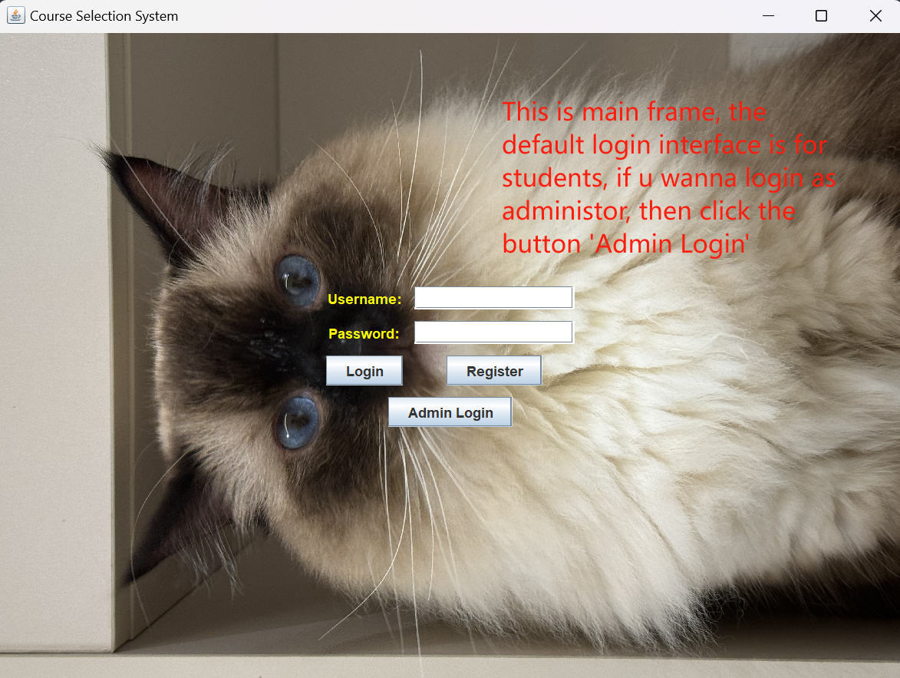

**Administrator Features**: The system provides administrators with tools to manage courses and view student information, aiding in the digitalization of teaching administration.

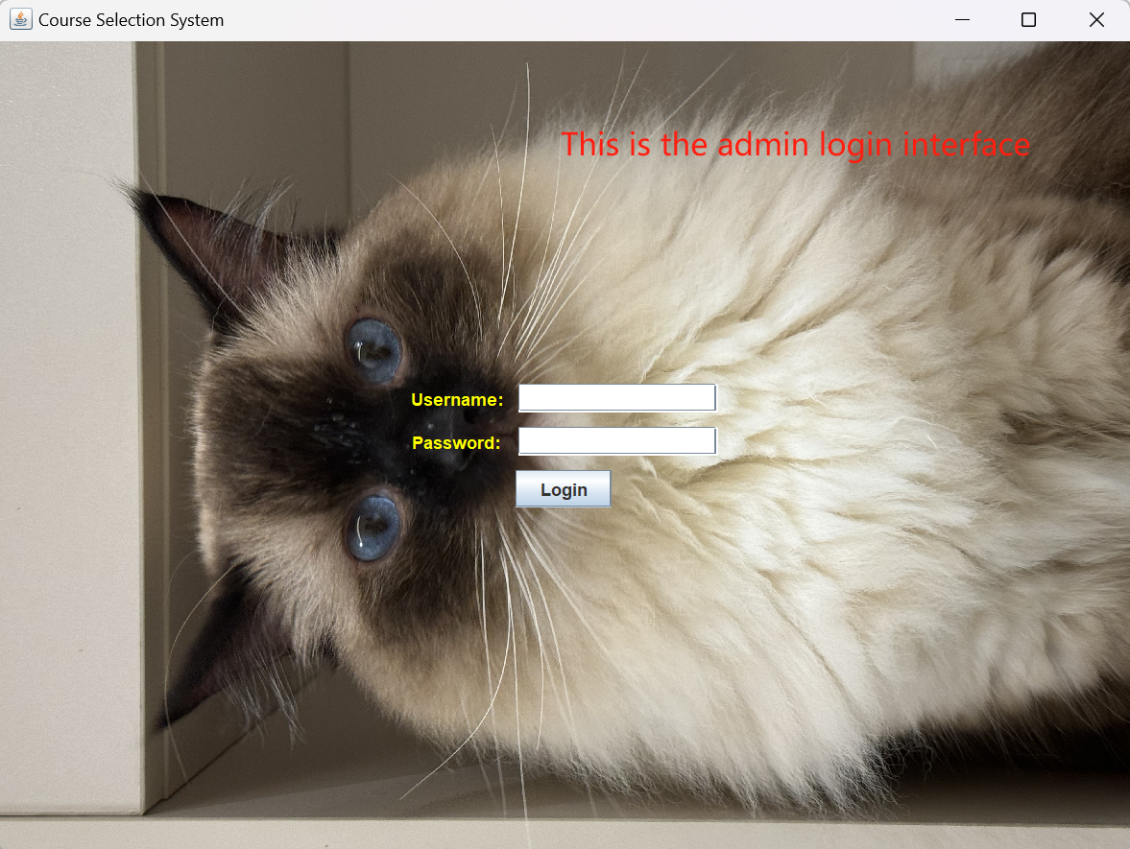

# 2. System Requirements

* Operating System: Windows, macOS, Linux
* Java Runtime Environment: JDK 8 or higher
* Database: MySQL 5.7 or higher

In this system, the doc folder stores usage guideline, the lib folder stores MySQL-connector, the res folder stores resource images and database backup files, the compiled executable Java class files are stored in the run folder, and finally the src folder saves the source code, which is classified into different software packages. The system file structure is shown as follows:

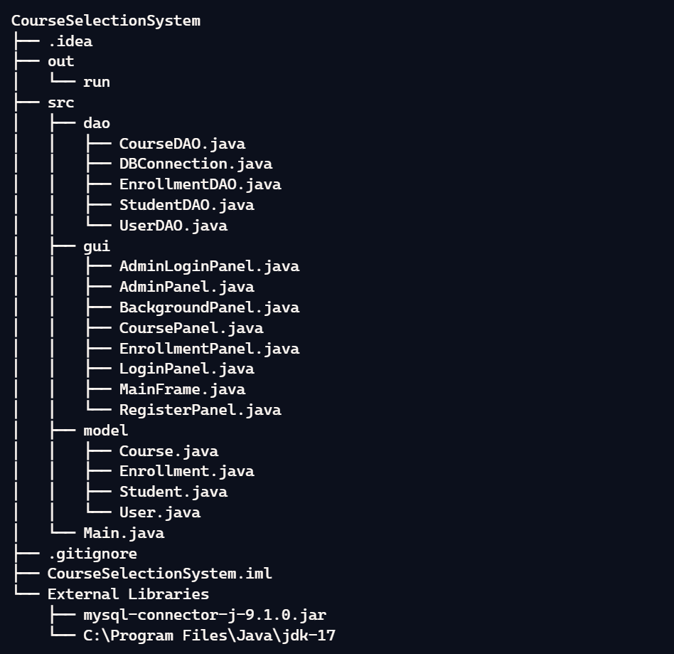

E-R diagram:

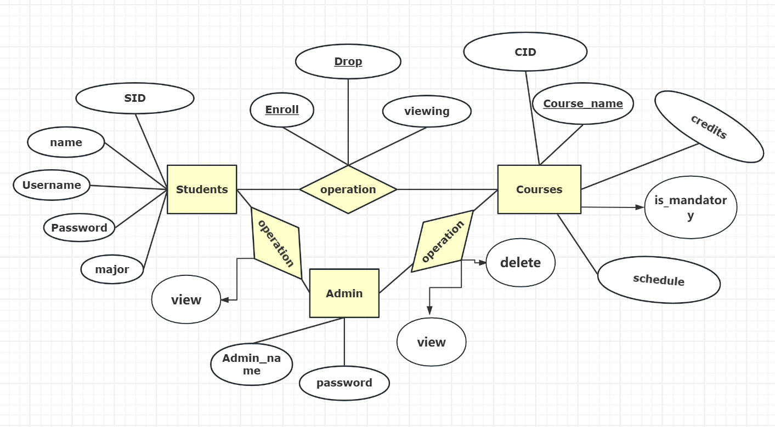

You can execute this system simply run the Main.java to run the whole system.

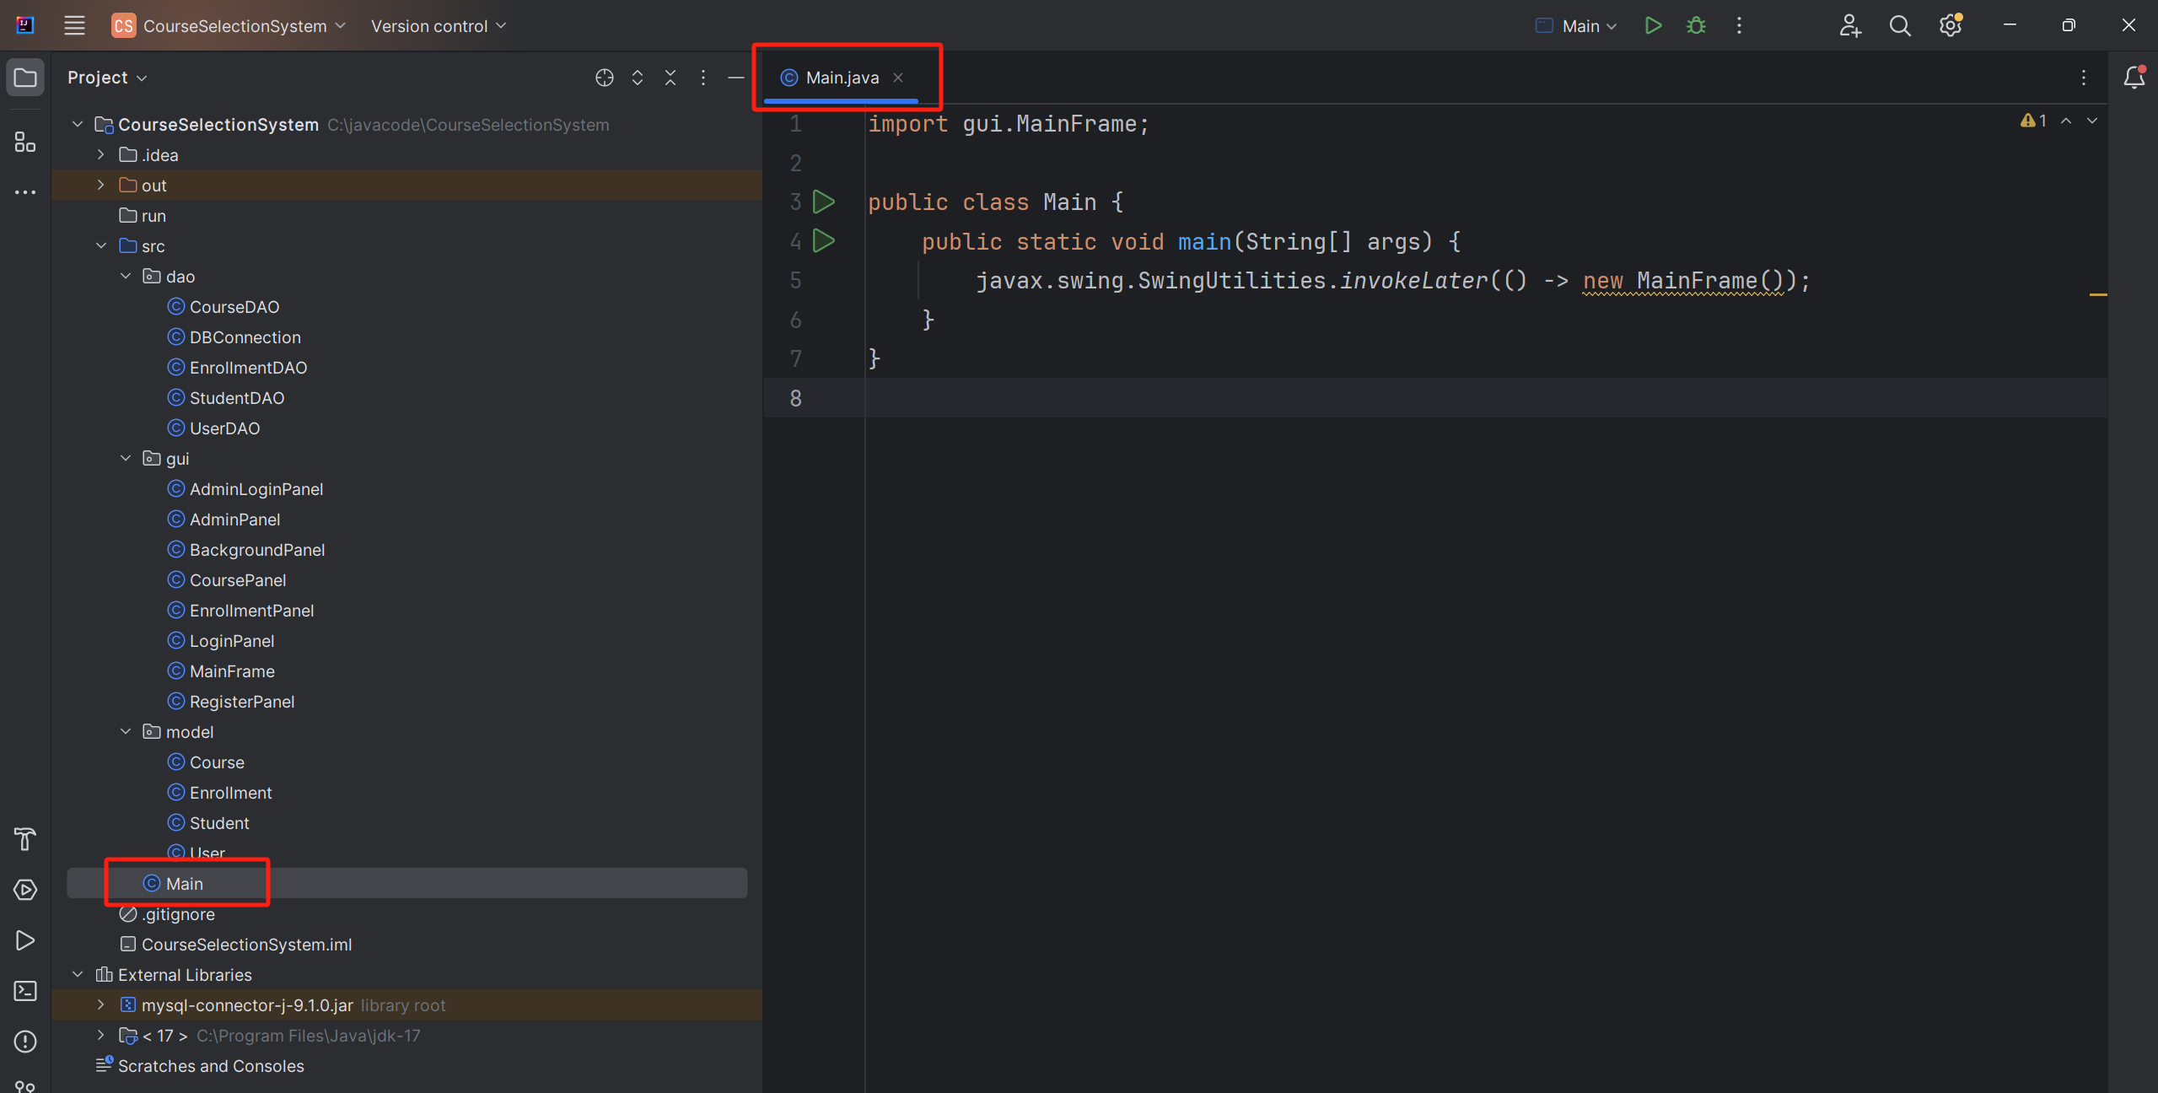

# 3. Installation and Startup

1. Ensure Java Runtime Environment and MySQL database are installed.
2. Download and unzip the project source code.
3. Open the project in an IDE (such as IntelliJ IDEA).
4. Configure the database connection information.
5. Run the Main.java file to start the system.

# 4. User Registration and Login

1. Open the system login interface.

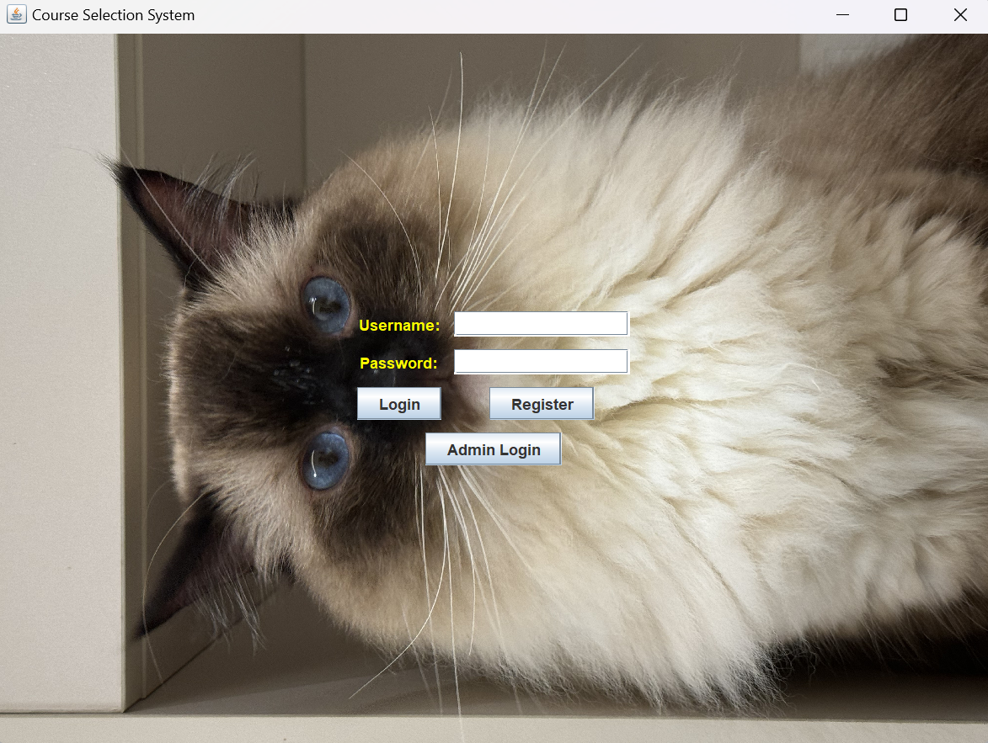

1. Click the "Register" button, fill in the username, password, student ID, name, and major, then click "Register" to complete registration.

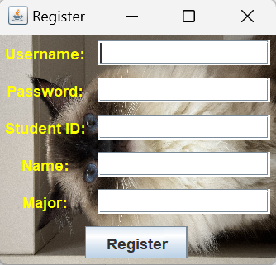

1. Log in to the system using the registered username and password.

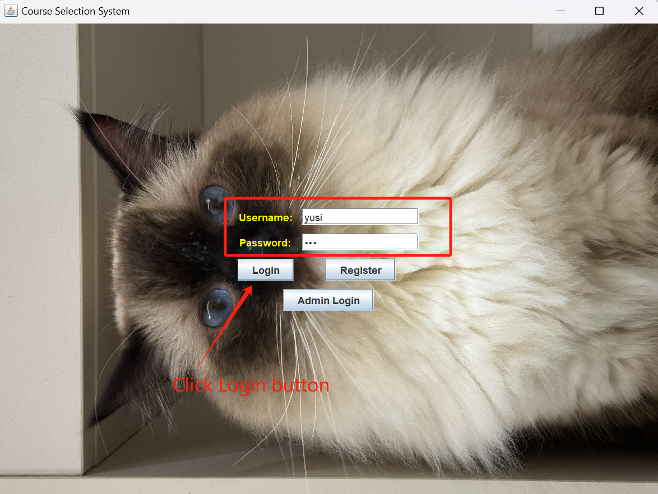

# 5. Student Features

## 5.1 Course Enrollment

1. After logging in, go to the course enrollment interface.

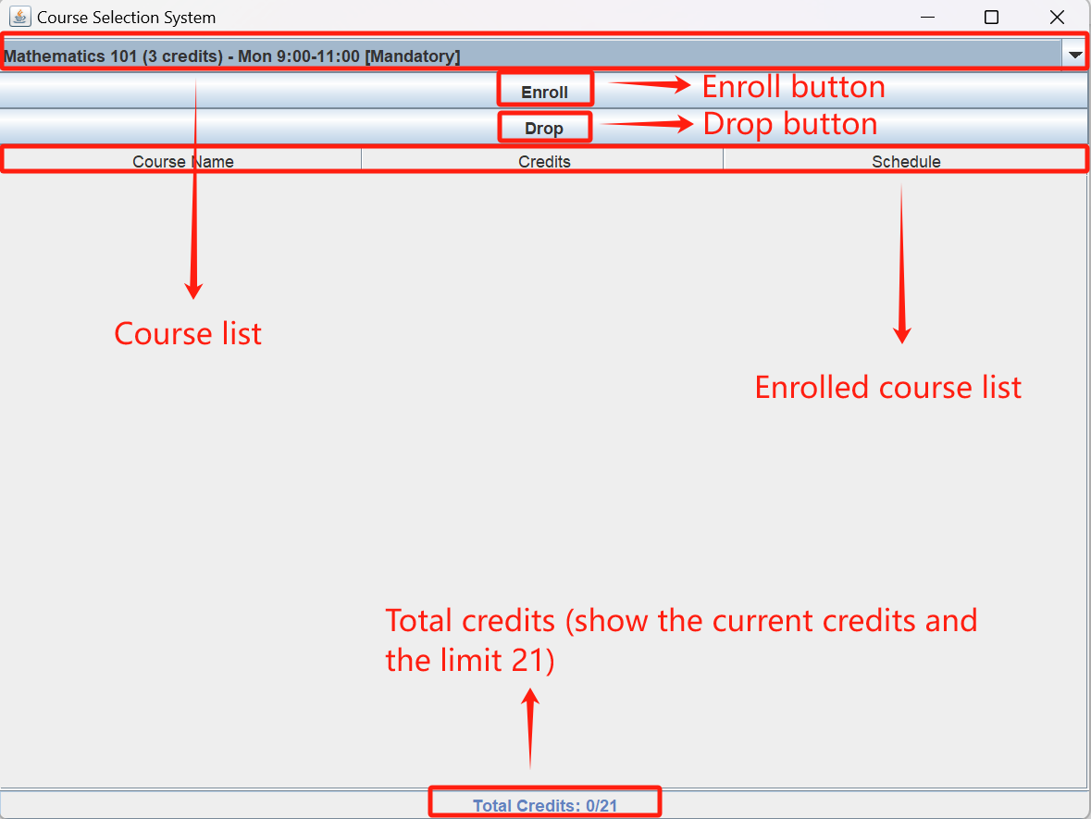

1. Select the desired course from the dropdown list. Mandatory courses will be marked with "[Mandatory]".

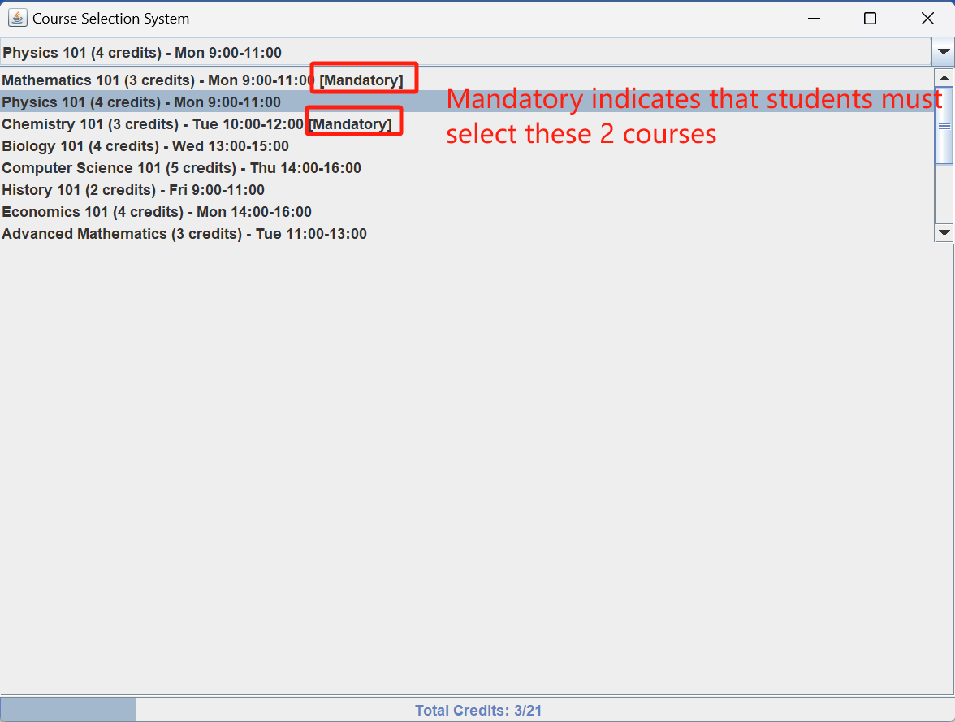

1. Click the "Enroll" button to enroll in the course. The system will check for credit and schedule conflicts.

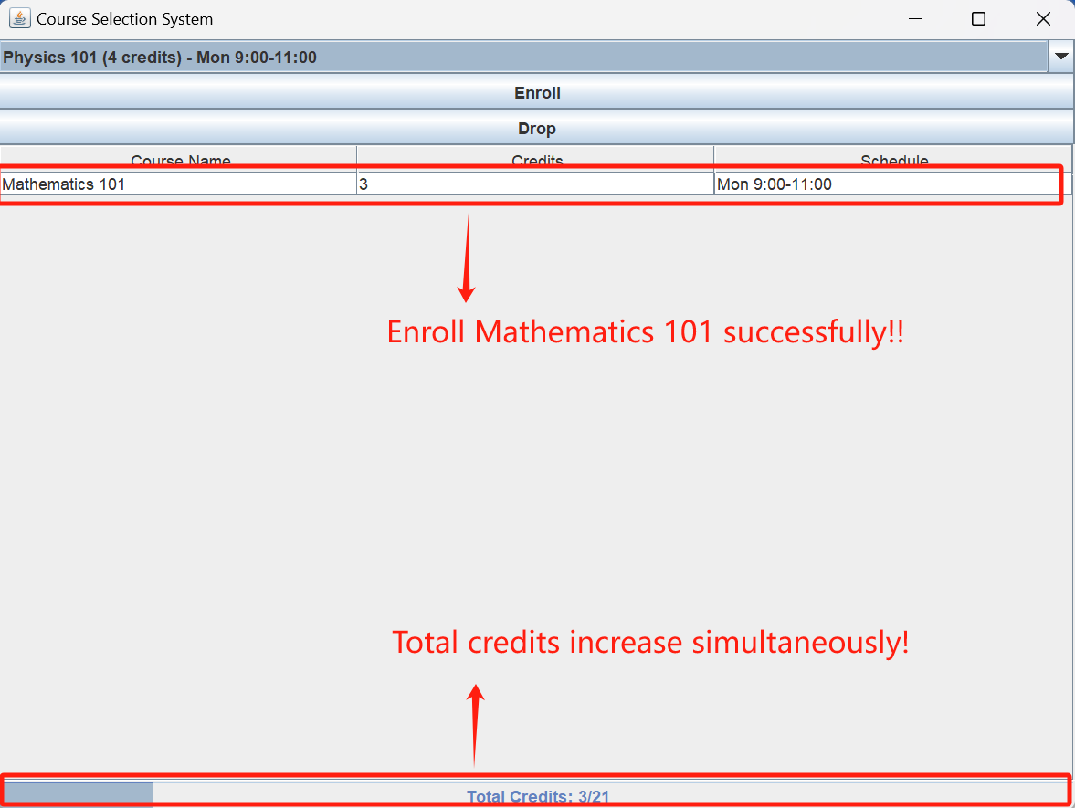

## 5.2 Dropping Courses

1. In the course enrollment interface, select a course from the list of enrolled courses.
2. Click the "Drop" button to drop the selected course.

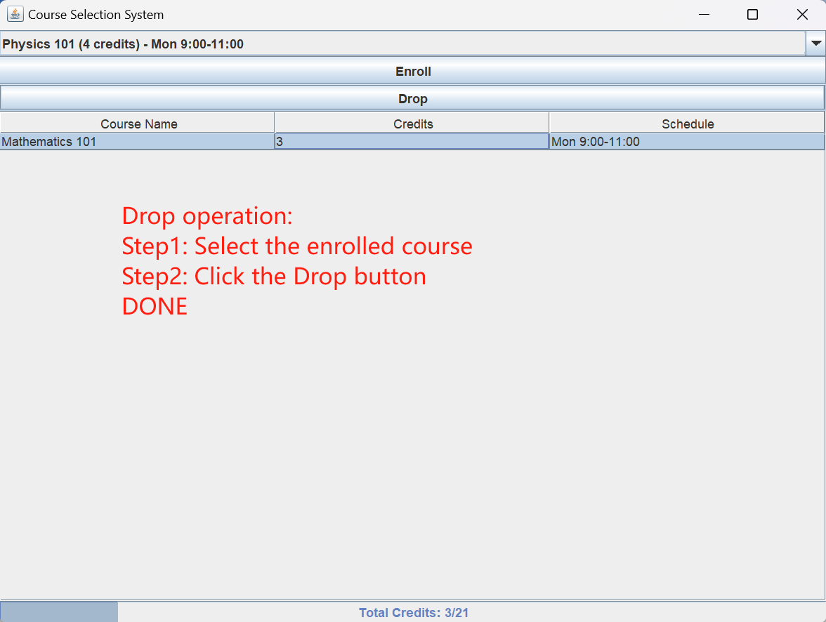

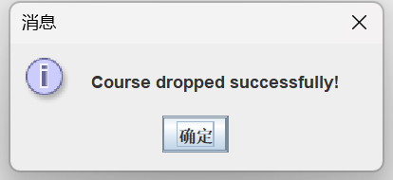

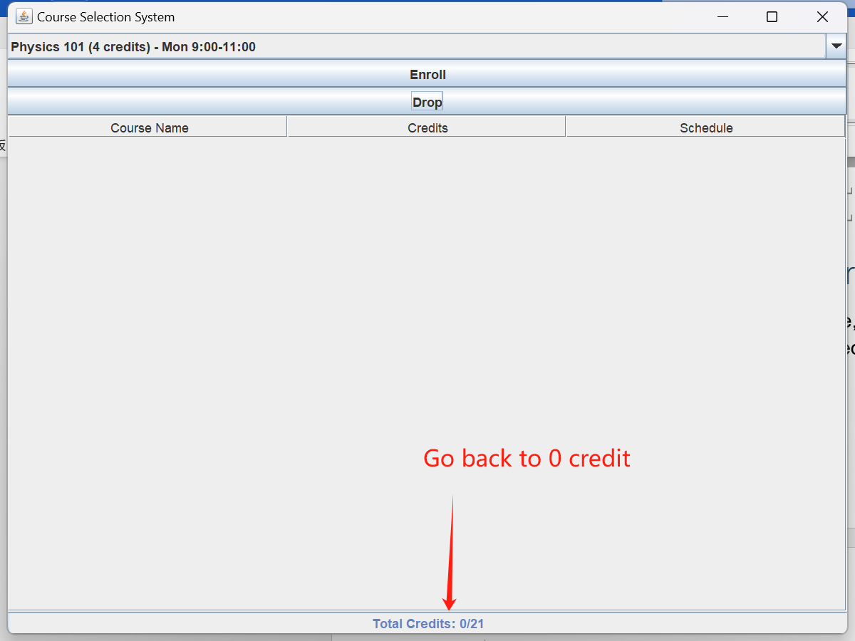

## 5.3 Viewing Enrolled Courses

1. In the course enrollment interface, you can view the list of currently enrolled courses and the total credit progress bar.

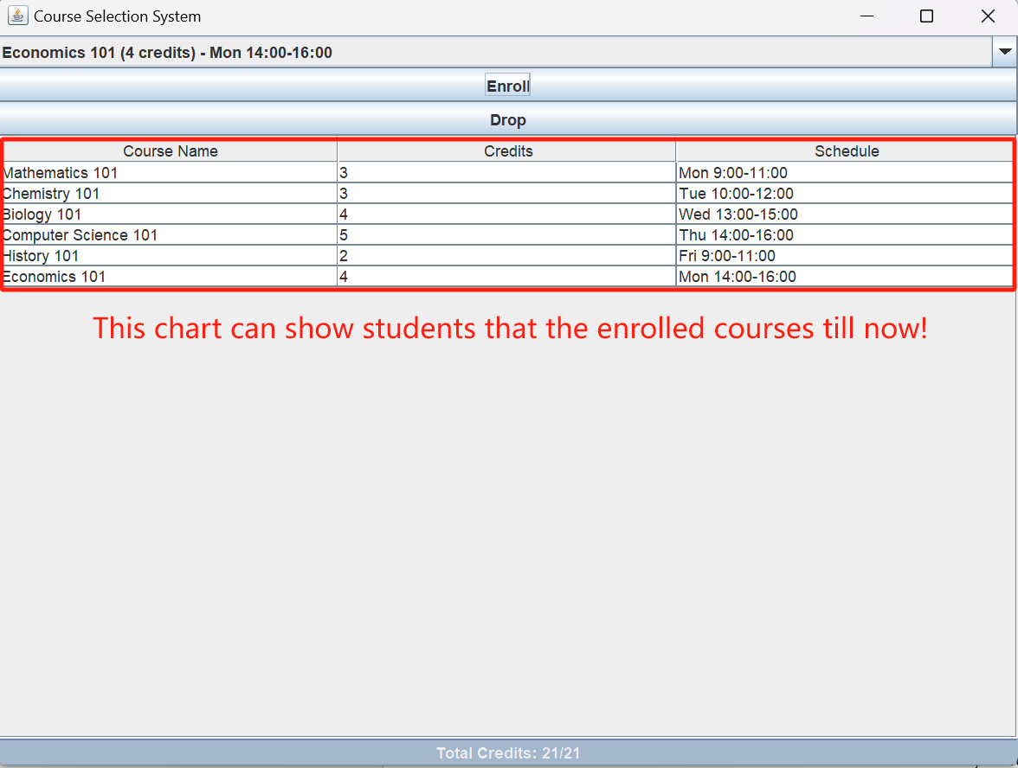

# 6. Administrator Features

## 6.1 Adding Courses

1. Log in with an administrator account.

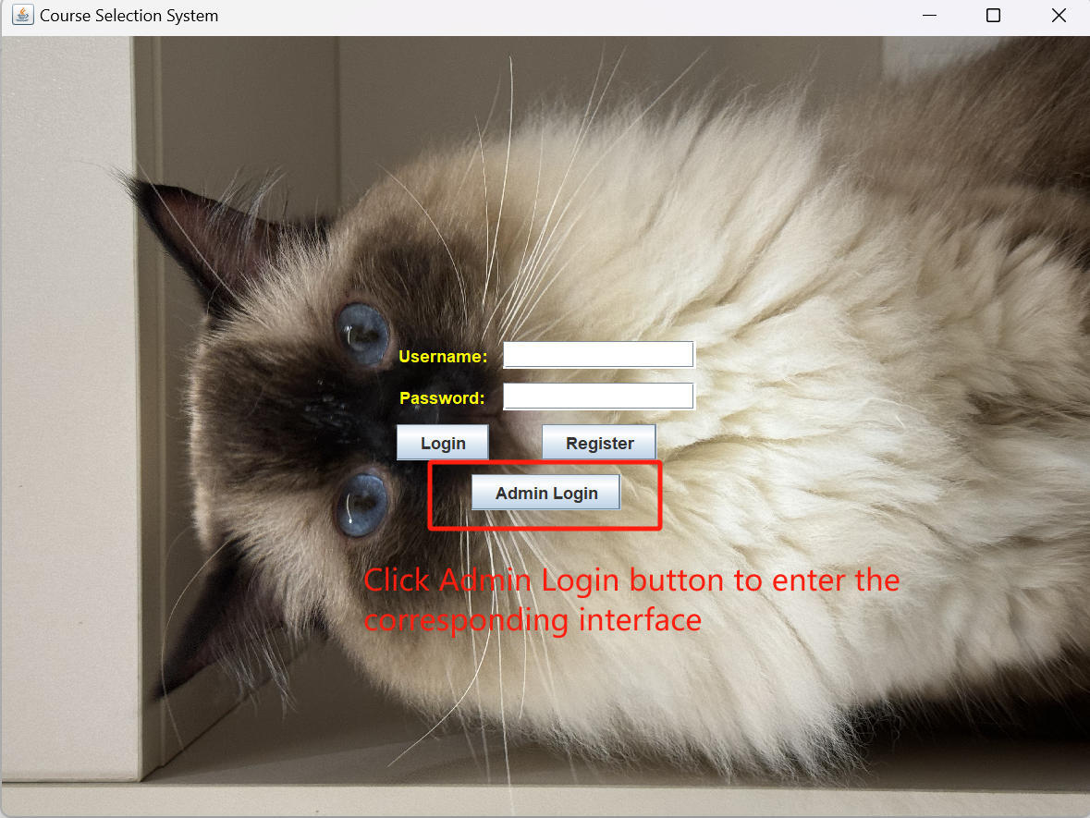

1. Go to the administrator panel.

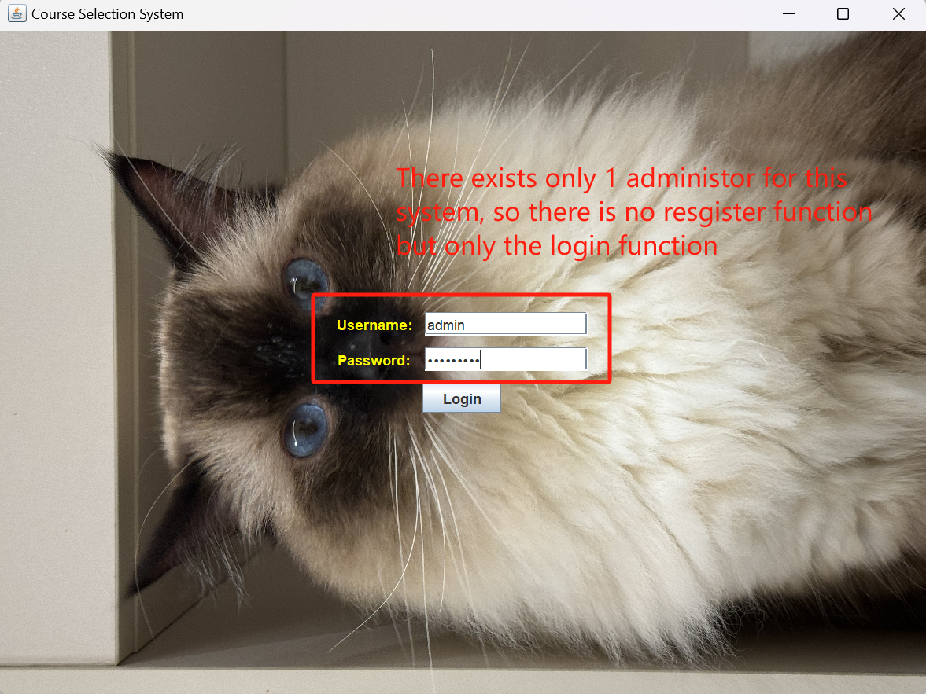

1. Click the "Add Course" button, enter the course name, credits, and schedule, then click to confirm adding the course.

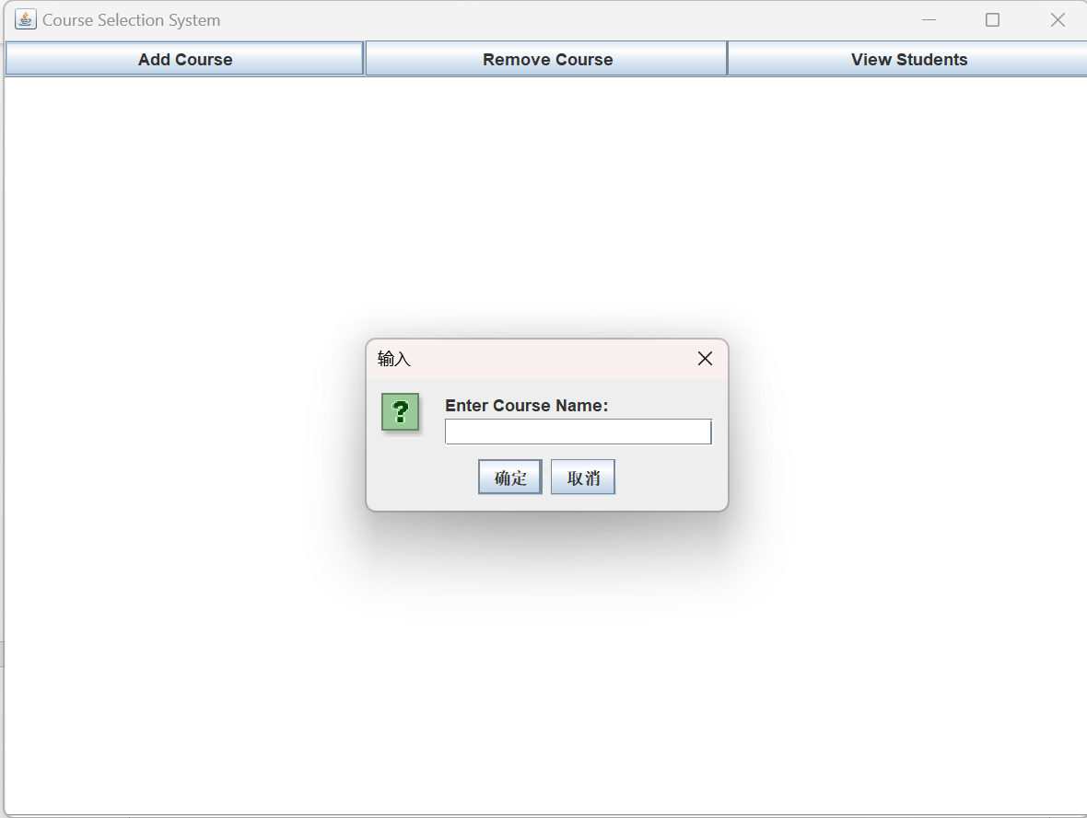

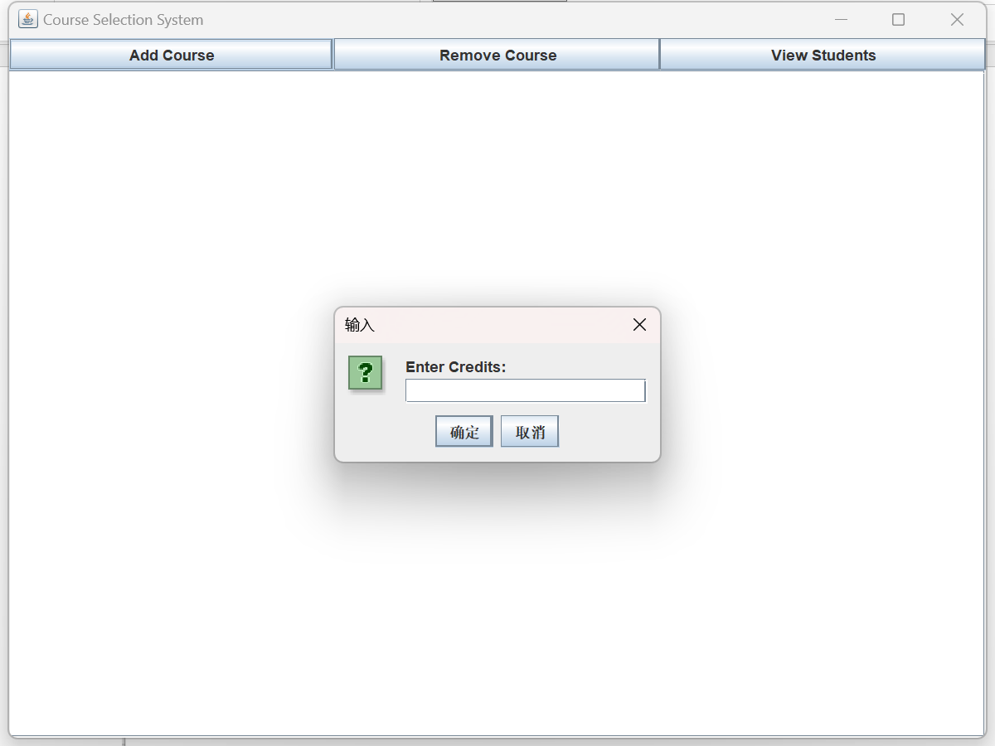

## 6.2 Removing Courses

1. In the administrator panel, click the "Remove Course" button.

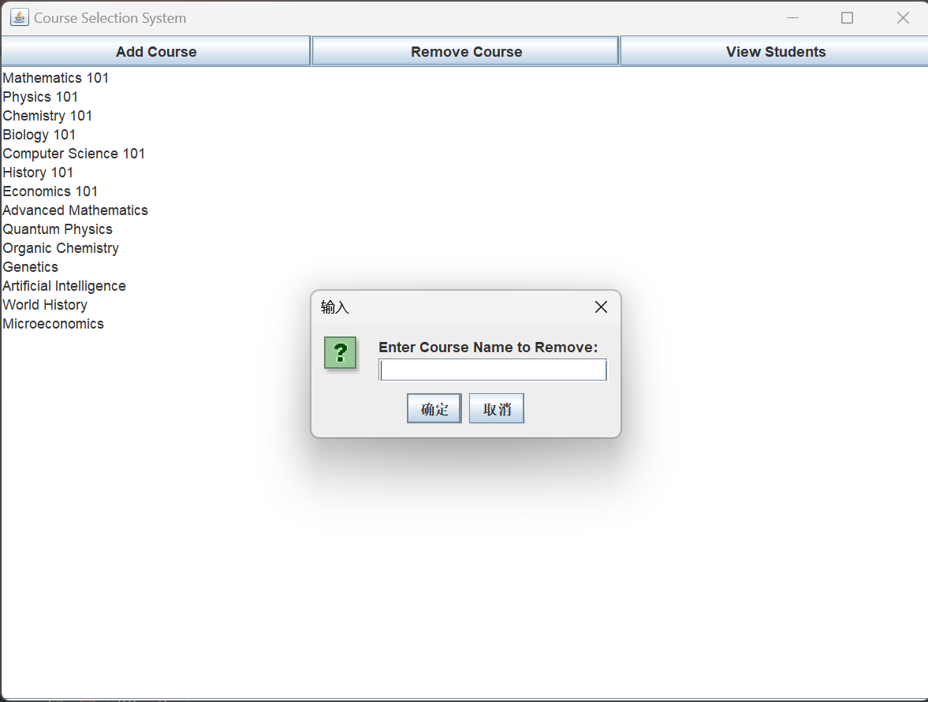

1. In the pop-up dialog, enter the name of the course to be removed and click to confirm deletion.



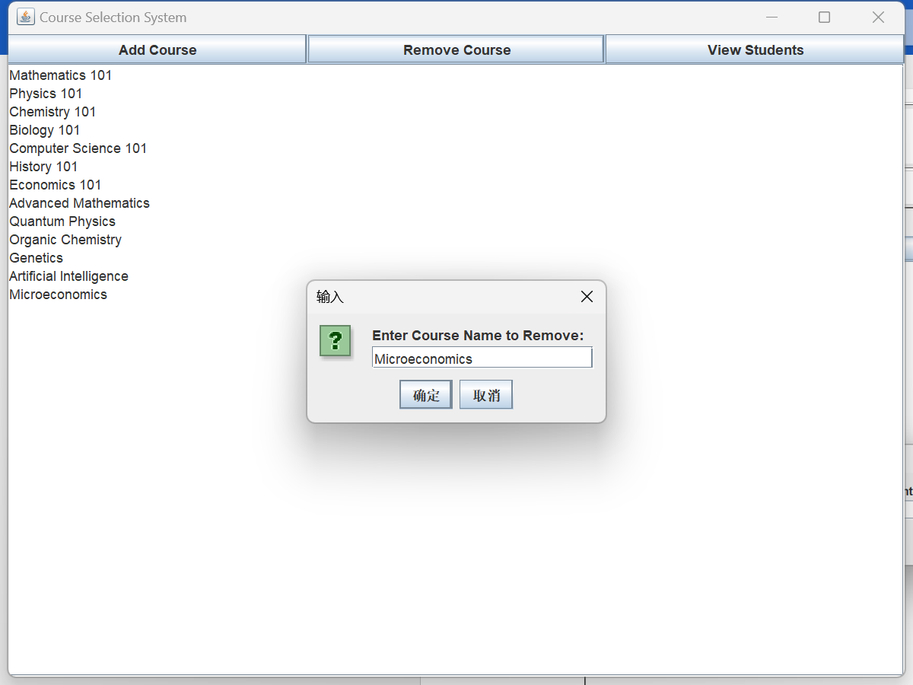

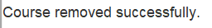

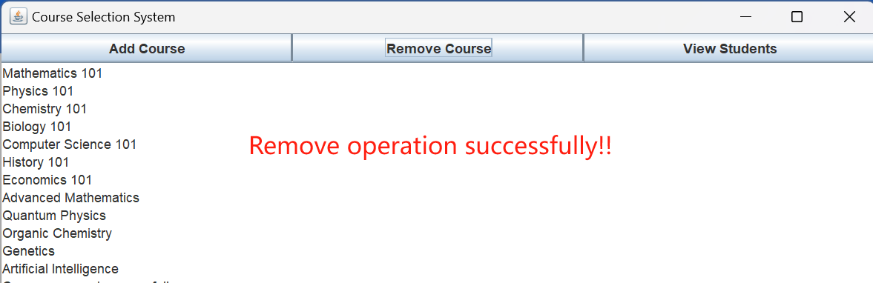

## 6.3 Viewing Student Information

1. In the administrator panel, click the "View Students" button.
2. The system will display all student information, including username, student ID, name, and major.

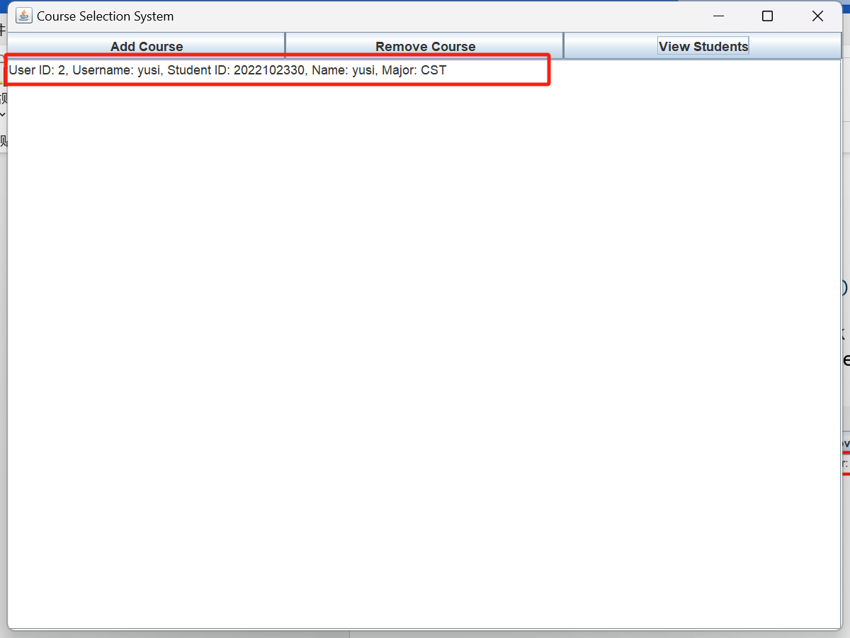

# 7. Some restricts and FAQs

* Can not choose courses that conflict with your schedule

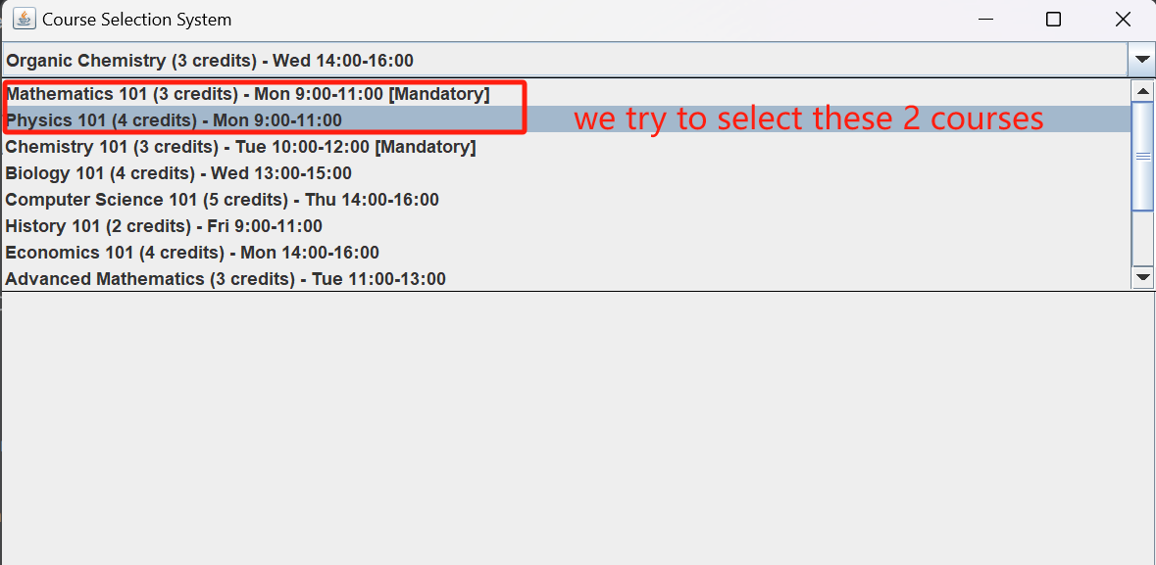

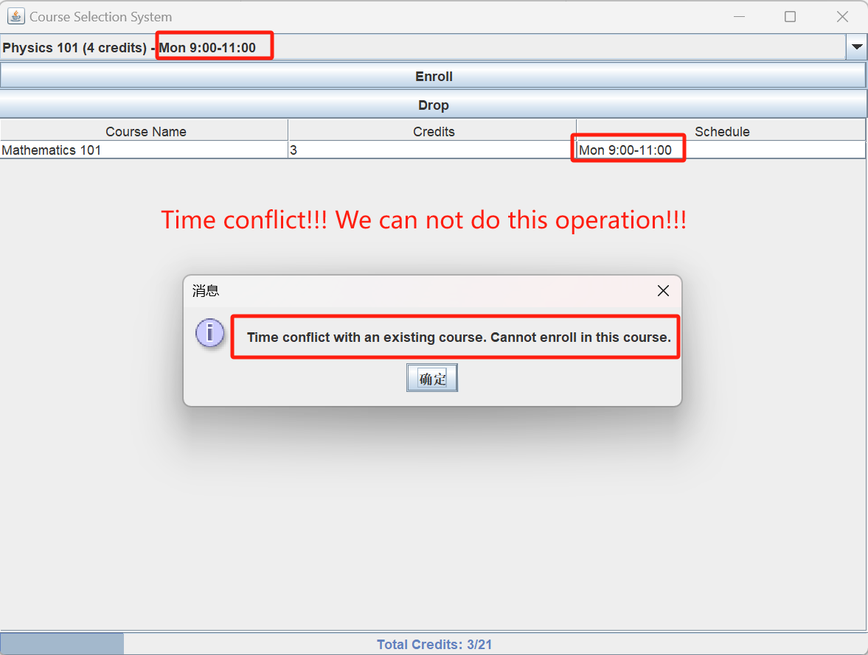

* The total credit limit per student is 21.

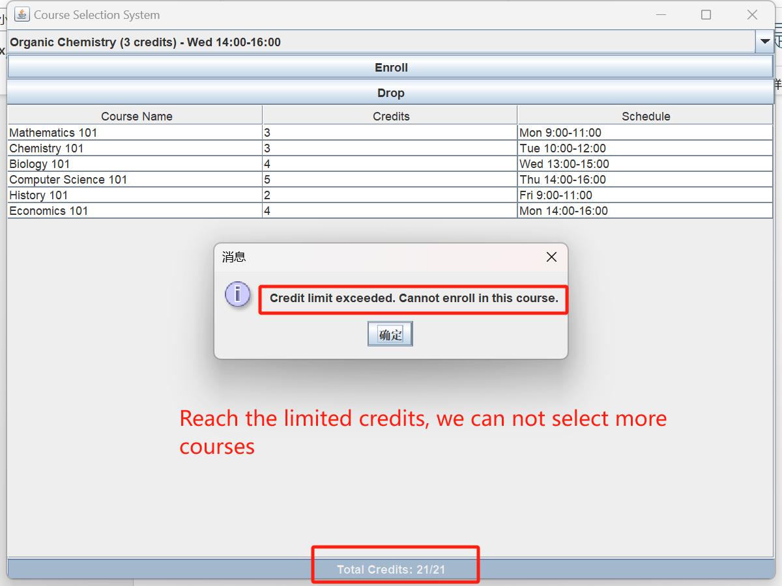

* Mandatory courses are marked with "[Mandatory]" and must be enrolled by students.
* If you encounter any issues, please contact the system administrator.